**PROGRAM [10]:**

class BlockWorldAgent:

    def solve(self, initial, goal):

        # Replace this with your actual implementation of the solve method

        # This is just a placeholder

        return f"Solving {initial} to {goal}"

def test():

    test_agent = BlockWorldAgent()

    initial_arrangement_1 = [["A", "B", "C"], ["D", "E"]]

    goal_arrangement_1 = [["A", "C"], ["D", "E", "B"]]

    goal_arrangement_2 = [["A", "B", "C", "D", "E"]]

    goal_arrangement_3 = [["D", "E", "A", "B", "C"]]

    goal_arrangement_4 = [["C", "D"], ["E", "A", "B"]]

    print(test_agent.solve(initial_arrangement_1, goal_arrangement_1))

    print(test_agent.solve(initial_arrangement_1, goal_arrangement_2))

    print(test_agent.solve(initial_arrangement_1, goal_arrangement_3))

    print(test_agent.solve(initial_arrangement_1, goal_arrangement_4))

    initial_arrangement_2 = [["A", "B", "C"], ["D", "E", "F"], ["G", "H", "I"]]

    goal_arrangement_5 = [["A", "B", "C", "D", "E", "F", "G", "H", "I"]]

    goal_arrangement_6 = [["I", "H", "G", "F", "E", "D", "C", "B", "A"]]

    goal_arrangement_7 = [["H", "E", "F", "A", "C"], ["B", "D"], ["G", "I"]]

    goal_arrangement_8 = [["F", "D", "C", "I", "G", "A"], ["B", "E", "H"]]

    print(test_agent.solve(initial_arrangement_2, goal_arrangement_5))

    print(test_agent.solve(initial_arrangement_2, goal_arrangement_6))

    print(test_agent.solve(initial_arrangement_2, goal_arrangement_7))

    print(test_agent.solve(initial_arrangement_2, goal_arrangement_8))

**OUTPUT [10]:**

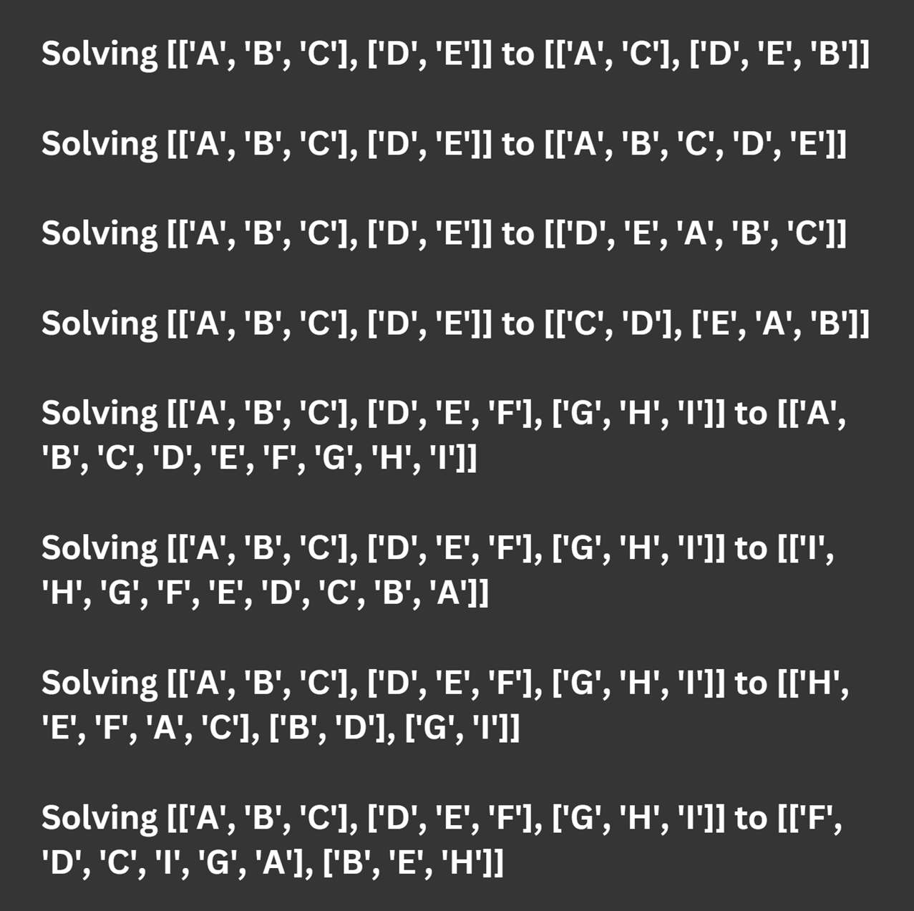

if __name__ == "__main__":

    test()